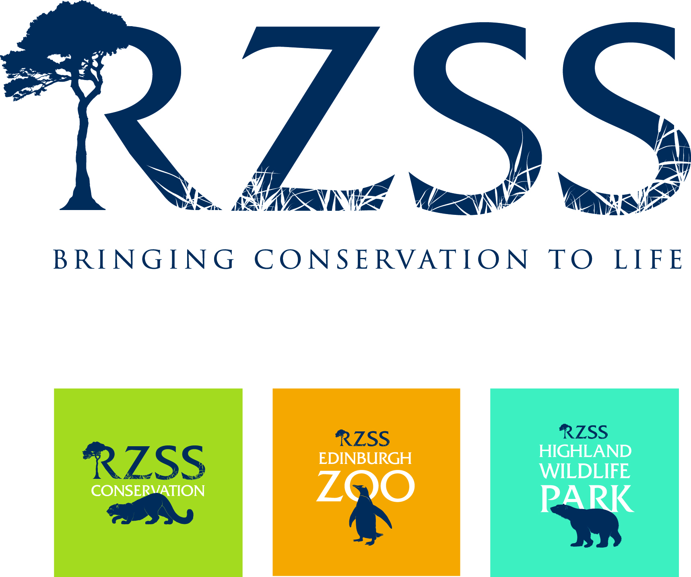

Researchers
Highland Wildlife Park

www.highlandwildlifepark.org.uk

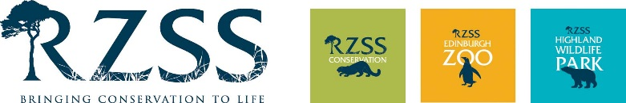

The Royal Zoological Society of Scotland (RZSS), a charity founded in 1909, owns and manages Edinburgh Zoo and the Highland Wildlife Park. The Highland Wildlife Park is a premier conservation/education focused visitor attraction based at Kincraig between Kingussie & Aviemore and features cold weather adapted species from around the world as well as indigenous Scottish species, some now extinct in the wild.

The Highland Wildlife Park is keen to encourage and support non-invasive research into animal behaviour and welfare by students. Your project will have to be approved before it begins but the Highland Wildlife Park will do what it can to support the work of students in return for a copy of their final projects.

Projects frequently concern group behaviour studies, although we are keen to explore many other avenues of research which may enhance the lives of our animals.

Researchers are recommended to make their stay with us as long as possible since finding a mutually beneficial routine and, in some cases, gaining the trust of the animal(s) in question can take some time. Therefore a stay of 3 weeks or longer is preferable (maximum 2 months). Please note also that the minimum age at which we take researchers who need to stay onsite is age 20.

We can offer basic bothy accommodation on site - often sharing will be required. A non-refundable fee of £100, payable on arrival, is charged for wear & tear, damage, admin, electricity, etc. We provide kitchen facilities and a shower room but you must supply your own food. You must also bring your own sleeping bag, towels, etc.

We can arrange transport from our nearest railway station at Kingussie but you must advise us of your arrival time beforehand.

Research students spend the majority of their time retrieving data to complete the project but because accommodation space is reserved for those who are actively working or researching at the Park, all preliminary work leading up to the research will be expected to be completed and submitted to us (in rough) before your arrival at the Park.

Please note this information will be held on file and treated confidentially. The information will only be shared among site managers. (Please print or type in the spaces provided).

1. STUDENT DETAILS
Student Name:
Date of birth:
Address:

Post Code:
Mobile Phone Number:
Personal email:

2. UNIVERSITY/COLLEGE DETAILS
Course title: | Course Level (HND, Degree, etc):
Start date of course: | Expected completion date of course:
Institution Name & Address:

Placement supervisor’s name & contact email address:

3. ACADEMIC QUALIFICATIONS. Please give details of all your academic studies from High School onwards
Subject studied | Level of study (GCSE/Highers/Degree/HND) | Date begun | Date finished | Grade attained | Institution name
4. NON-ACADEMIC QUALIFICATIONS & TRAINING, e.g. First Aid, sheep shearing, etc.
Subject studied | Level of study (if any) | Date begun | Date finished | Grade attained (if any) | Institution name

5. The proposed title of your project
6. Objective of the research

Preferred start & end dates of placement (dd/mm/yy). Maximum 2 months |  | Start: | End:
Would you like to be provided with accommodation in our students’ bothy? |  |  | YES | NO
Due to the nature of the work placements, participants must have good mobility and a reasonable level of fitness. Due to practicality, personal wellbeing and Health & Safety it is unfortunately not possible to consider those with a disability, certain health issues, learning difficulty, or special needs.
Please briefly describe any health issues.

- Note that you should treat this placement as you would a real job – you must be professional & fit in with the team.
- If English is not your first language, note that you must be able to fully understand verbal instructions & communicate/socialise with staff. If your spoken English is poor, think carefully before submitting your application.
- If you wish to submit your application electronically, please email this form along with a colour head & shoulders photo size 45mmx35mm (the photo you would use to apply for a passport) as a separate attachment in jpg format & the names of your 2 referees (references should be from work {either paid or voluntary} or educational supervisors) to jmorse@rzss.org.uk. Note that if you have undertaken work experience at an animal facility, at least one of your references must be from the relevant facility. You must then ask your referees to email their references directly to the same email address, being sure to quote your full name in the email subject.
- If you are submitting your application by post, please return this form with a colour head & shoulders photo, specification as in 3 above, and your references (references should be from work {either paid or voluntary} or educational supervisors). Note that if you have undertaken work experience at an animal facility, at least one of your references must be from the relevant facility. References should be word processed and placed in a sealed envelope with the referee’s signature over the seal. Post to:-
Private & Confidential, Animal Dept Administrator
Highland Wildlife Park
Kincraig, Kingussie
PH21 1NL
If you wish to talk about your placement or check availability, please feel free to phone (+44) (0)1540 651970 or email jmorse@rzss.org.uk

Please note that no applications will be accepted without receipt of references and ID photo IN THE CORRECT FORMAT. Note also that the first step in the selection process for anyone wishing to participate in our research programme is for you to demonstrate that you can follow simple instructions and complete the application process as required.

I declare that all of the details I have provided on this form are, to the best of my knowledge, complete and accurate, I accept that my placement will be terminated if any details are found to be misleading
Signed | Date
Application checklist

Application form filled out truthfully and in full
Colour ID photo

2 references from work or academic supervisors

Highland Wildlife Park is owned by the conservation charity the Royal Zoological Society of Scotland. Charity No SC004064

