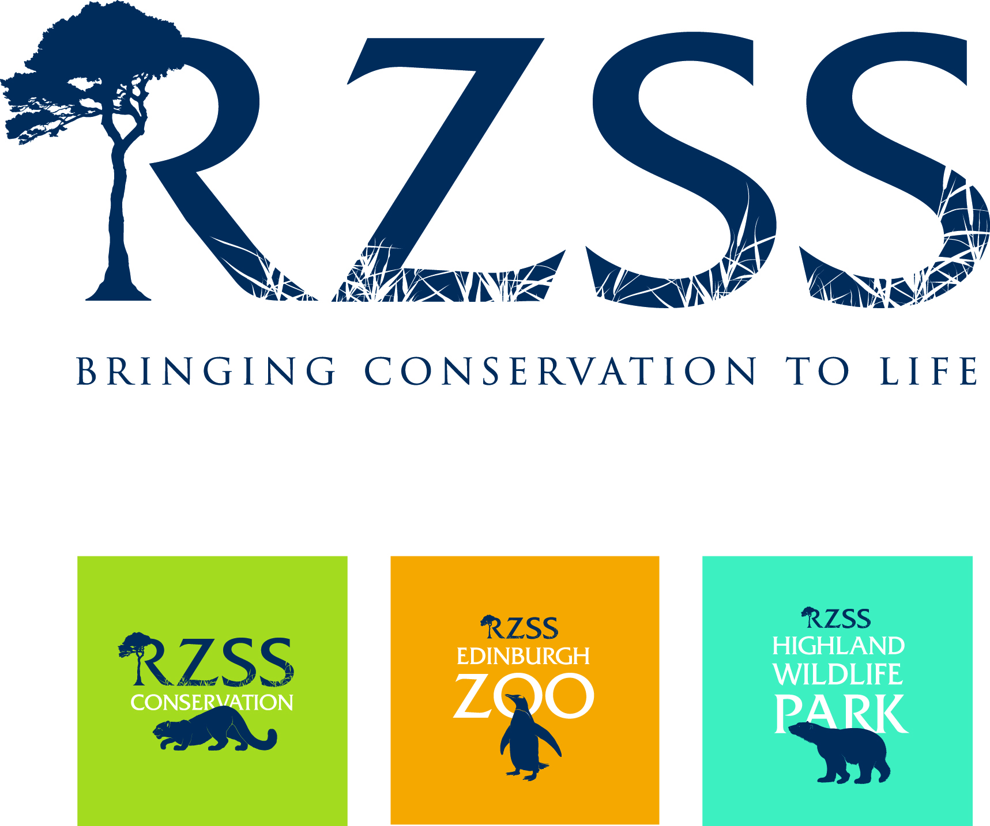

Education Work Placement
Highland Wildlife Park

www.highlandwildlifepark.org.uk

The Royal Zoological Society of Scotland (RZSS), a charity founded in 1909, owns and manages Edinburgh Zoo and the Highland Wildlife Park. The Highland Wildlife Park is a premier conservation/education focused visitor attraction based at Kincraig between Kingussie & Aviemore and features cold weather adapted species from around the world as well as indigenous Scottish species, some now extinct in the wild.

The Highland Wildlife Park takes an active role in the education of work placement students. This post involves many of the aspects of education within a zoo environment and includes interacting with schools and other groups visiting for educational purposes. A high emphasis is placed on the place of zoos in conservation.

Work placement applicants are normally required to be students currently undergoing a course related to education or conservation, although applications are also accepted from newly graduated students as well as highly qualified individuals (e.g. education staff from different zoos wishing to form an exchange).

Students are recommended to make their stay as long as possible since many have commented on the steep learning curve that is involved. It can take at least a week to settle in and to become used to the routine therefore a stay of 4 weeks or longer is required. Because of the popularity of this scheme, the maximum placement period is restricted to two months. Please note also that the minimum age at which we take students is age 20.

We can offer basic bothy accommodation on site - often sharing will be required. A non-refundable fee of £100, payable on arrival, is charged for wear & tear, damage, admin, electricity, etc. We provide kitchen facilities and a shower room but you must supply your own food. You must also bring your own sleeping bag, towels, etc.

We can arrange transport from our nearest railway station at Kingussie but you must advise us of your arrival time beforehand.
Education Work Placement Duties

Education students will be provide education services to the general public & be able to interact with the public. This will allow the general public the opportunity to ask questions and hopefully allay any concerns or potential problems that can be easily talked about with an informed Education work placement student.

The Education students will liaise with
- Education Officers (Jasper) To get daily information and coordination and allocation of duties
- Animal section Education Work placements coordinator (Jan)

Core activities for the Education students would be:
- · Opening and running the Education Centre - The touch tables display a range of bio-facts including skins, skulls and other bio-facts for handling and discovery. Again, the emphasis is on facilitating learning in an informal and enjoyable way.

- · Informal bio-fact talks around the exhibits - These would be located at key species / exhibits around the Park, e.g. at the wolf, tiger, polar bear and at the main reserve viewing areas using the relevant bio-facts for that area. These areas are all covered and will allow the use of bio-facts without potential weather damage.

- · Exhibit interpretation - Education students are placed alongside members of education staff at key animal exhibits to chat to visitors, help them spot the animals and answer a range of questions. This is a priority activity and requires Education students to be confident and pro-active in approaching visitors and engaging them in conversation. The Education students would visit the exhibits at timings opposite the keeper feeds/talks, to ensure maximum visitor and Education students/staff meetings.

- · School and Colleges - Undertake all aspects of the formal and informal education program of the Society at Highland Wildlife Park ensuring that, as a minimum, the schools’ program meets the requirements of the relevant school’s curricula and education needs (giving tours of the Park). This may include helping to design and plan new lessons and presentations.

NB. You will notice that there is little direct contact with live animals, although they are all around you; this is an important point which should help to avoid any misconceptions about the role of an Education students on this program.

Education students will not be reallocated to replace paid staff, unless they are suitably paid for their services i.e. gift aid, café, shop, and gate etc.

The Education student’s position will be classed as separate to the Animal student position.

General Guidance
You will be expected to show a modicum of initiative and a sound work ethic. The international zoo and conservation community is quite small and well connected and you may require a reference from us in the future to help start your own career. We expect you to pay attention, learn, impress us and enjoy your time at the Park.

Please note this information will be held on file and treated confidentially. The information will only be shared among site managers. (Please print or type in the spaces provided).

1. STUDENT DETAILS
Student Name:
Date of birth:
Address:

Post Code:
Mobile Phone Number:
Personal email:

2. UNIVERSITY/COLLEGE DETAILS
Course title: | Course Level (HND, Degree, etc):
Start date of course: | Expected completion date of course:
Is a placement a mandatory element of your course?
Institution Name & Address:

Placement supervisor’s name & contact email address:

3. BRIEF DESCRIPTION OF PLACEMENT FROM YOUR ACADEMIC INSTITUTION’S PERSPECTIVE, i.e. what do they expect you to achieve during your placement? (Daily diary, written essays, photographic evidence, etc)
4. ACADEMIC QUALIFICATIONS. Please give details of all your academic studies from High School onwards
Subject studied | Level of study (GCSE/Highers/Degree/HND) | Date begun | Date finished | Grade attained | Institution name

5. NON-ACADEMIC QUALIFICATIONS & TRAINING, e.g. First Aid, sheep shearing, etc.
Subject studied | Level of study (if any) | Date begun | Date finished | Grade attained (if any) | Institution name
6. Do you have any particular areas within the Education Department in which you want to work?

7. Do you have any experience in conservation education?
8. Do you have any knowledge of any of the species currently in the collection at the Highland Wildlife Park?
9. Please give details of any relevant experience which will support your application

Preferred start & end dates of placement (dd/mm/yy). Maximum 2 months |  | Start: | End:
Would you like to be provided with accommodation in our students’ bothy? |  |  | YES | NO
Due to the nature of the work placements, participants must have good mobility and a reasonable level of fitness. Due to practicality, personal wellbeing and Health & Safety it is unfortunately not possible to consider those with a disability, certain health issues, learning difficulty, or special needs.
Please briefly describe any health issues.

- Please make sure you have read & understood the job description on page 3. Note that you should treat this work placement as you would a real job – you must be professional & fit in with the team.
- If English is not your first language, note that you must be able to fully understand verbal instructions & communicate/socialise with staff. If your spoken English is poor, think carefully before submitting your application.
- If you wish to submit your application electronically, please email this form along with a colour head & shoulders photo size 45mmx35mm (the photo you would use to apply for a passport) as a separate attachment in jpg format & the names of your 2 referees (references should be from work {either paid or voluntary} or educational supervisors) to jmorse@rzss.org.uk. Note that if you have undertaken work experience at an animal facility, at least one of your references must be from the relevant facility. You must then ask your referees to email their references directly to the same email address, being sure to quote your full name in the email subject.
- If you are submitting your application by post, please return this form with a colour head & shoulders photo, specification as in 3 above, and your references (references should be from work {either paid or voluntary} or educational supervisors). Note that if you have undertaken work experience at an animal facility, at least one of your references must be from the relevant facility. References should be word processed and placed in a sealed envelope with the referee’s signature over the seal. Post to:-
Private & Confidential, Animal Dept Administrator
Highland Wildlife Park
Kincraig, Kingussie
PH21 1NL
If you wish to talk about your placement or check availability, please feel free to phone (+44) (0)1540 651970 or email jmorse@rzss.org.uk

Please note that no applications will be accepted without receipt of references and ID photo IN THE CORRECT FORMAT. Note also that the first step in the selection process for anyone wishing to participate in our work placement programme is for you to demonstrate that you can follow simple instructions and complete the application process as required.

I declare that all of the details I have provided on this form are, to the best of my knowledge, complete and accurate, I accept that my placement will be terminated if any details are found to be misleading
Signed | Date
Application checklist

Application form filled out truthfully and in full
Colour ID photo

2 references from work or academic supervisors

Highland Wildlife Park is owned by the conservation charity the Royal Zoological Society of Scotland. Charity No SC004064

