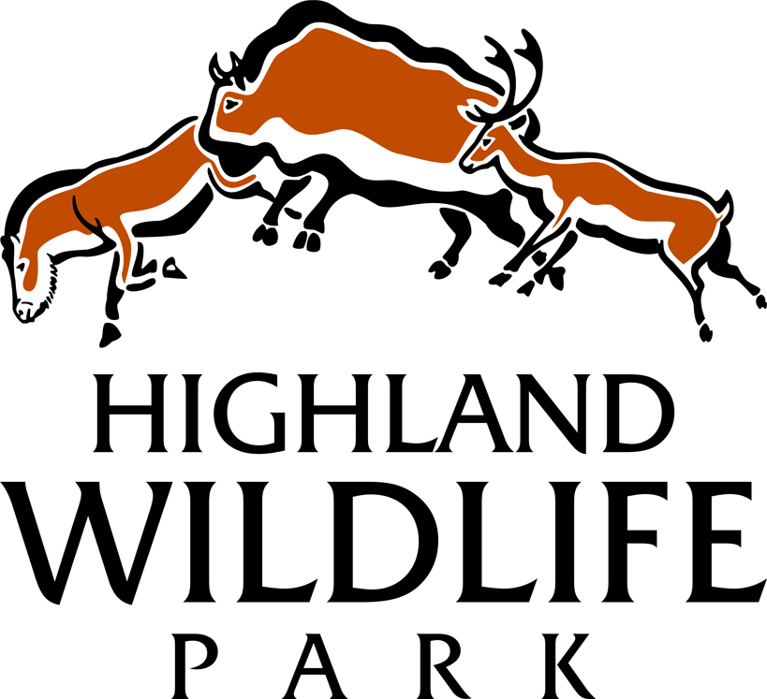

Researchers

www.highlandwildlifepark.org.uk

The Royal Zoological Society of Scotland (RZSS), a charity founded in 1909, owns and manages Edinburgh Zoo and the Highland Wildlife Park. The Highland Wildlife Park is a conservation/education focused visitor attraction based at Kincraig, between Kingussie & Aviemore, and features cold weather adapted species from around the world as well as indigenous Scottish species, some now extinct in the wild.

The Highland Wildlife Park is keen to encourage and support non-invasive research into animal behaviour and welfare by students. Your project will have to be approved before it begins but the Highland Wildlife Park will do what it can to support the work of students in return for a copy of their final projects.

Projects frequently concern group behaviour studies, although we are keen to explore many other avenues of research which may enhance the lives of our animals.

Researchers are recommended to make their stay with us as substantial as possible since finding a mutually beneficial routine and, in some cases, gaining the trust of the animal(s) in question can take some time. Therefore a stay of 3 weeks or longer is preferable (maximum 2 months). Please note also that the minimum age at which we take researchers who need to stay onsite is age 20.

We can offer limited free bothy accommodation on site (a non-refundable admin fee of £100 is required); usually sharing will be required. We provide kitchen facilities and a shower room; you must supply your own food, sleeping bag, etc. There are numerous bed and breakfast, self-catering and bunkhouse facilities within a 5-mile radius for those researchers who wish to avail themselves of these but the cost must be borne by the researcher themselves. If staying offsite, you must either purchase a research pass at a cost of £20 which gives you access into the Park during opening hours for the duration your project, or have a valid adult season pass which gives you membership for a whole year & can therefore be used out-with your research period.

Research students spend the majority of their time retrieving the data to complete the project but because bunk space is reserved for those who are actively working or researching at the Park, all preliminary work leading up to the research will be expected to be completed and submitted to us (in rough) before your arrival at the Park. During the time that you are not actively retrieving data for your project you will be expected to aid in the husbandry of the animals kept at the park.

First name
Surname
Date of Birth
House name / number
Street
Town
City
County
Country (If outside UK)
Post code
Contact telephone number
Email Address
Mobile telephone number
University/Institution

Academic qualifications;  Please give details of all of your academic studies from High school onwards | Subject  studied | Level of study (GCSE / Highers/ Degree / HND) | Date begun | Date finished | Grade attained |  | Institution name
Non-academic qualifications and training  E.g. First aid, Off road driving, Sheep shearing etc | Subject studied | Level of study (if any) | Date begun | Date finished | Grade attained (if any) | Institution name

The proposed title of your project
Objective of the research

Please give us a brief idea of your methodology
Why would you like to do this research at the Highland Wildlife Park?

Preferred start and end dates of placement (dd/mm/yy) Maximum 2 months
Would you like to be provided with accommodation in our volunteer bothy? |  |  |  | Yes |  | No
Do you have any disabilities, allergies, or health conditions that we may need to plan around, given that much of your time will be spent out of doors? |  |  |  | Yes |  | No
If yes, please briefly describe
- If English is not your first language, note that you must be able to fully understand verbal instructions & communicate/socialise with staff. If your spoken English is poor, think carefully before submitting your application.
- If you wish to submit your application electronically, please email this form along with a colour head & shoulders photo size 45mmx35mm (the photo you would use to apply for a passport) in jpg format & the names of your two referees (references should be from work [either paid or voluntary] or educational supervisors) to jmorse@RZSS.org.uk. You must then ask your referees to email their references directly to the same address, being sure to quote your full name in the email subject
- If you are submitting your application by post, please return this form with a colour head & shoulders photo size 45mmx35mm (the photo you would use to apply for a passport) and your references (references should be from work [either paid or voluntary] or educational supervisors. They should be word processed and in a sealed envelope with a signature from the person making the reference over the seal) to;

Private & Confidential
Animal Dept Administrator
The Highland Wildlife Park
Kincraig
Kingussie
Inverness-shire
PH21 1NL
If you wish to talk about your placement or check date availability, please feel free to phone (+44) (0)1540 651 970 or email jmorse@rzss.org.uk

Please note that no applications will be accepted without receipt of references and ID photo IN THE CORRECT FORMAT. Note also that the first step in the selection process for anyone wishing to participate in our internship programme is for you to demonstrate that you can follow simple instructions and complete the application process as required.
colour passport-type photo (in jpg format if emailed)
I declare that all of the details I have provided on this form are, to the best of my knowledge, complete and accurate, I accept that my placement will be terminated if any details are found to be untrue
Signed |  |  | Date
Application checklist
- Application form filled out truthfully and in full
- Colour passport-type photo
- 2 references from work or academic supervisors

Highland Wildlife Park is owned by the conservation charity the Royal Zoological Society of Scotland. Charity No SC004064

